***Project Phase III Report***

***On***

**Snack Shack Cafe (Website)**

**Submitted for the requirement of**

**Project course**

BACHELOR OF ENGINEERING

**COMPUTER SCIENCE & ENGINEERING**



**Submitted to: Submitted By:**

(Namrata & Ecode – E13783)Darshan (20BCS2353)

**Project Teacher (Supervisor)** Sayan Sarkar (20BCS2299)

Atul (20BCS2271)

**Co Supervisor Signature**

(Akshay Kumar & E Code -E13385)

**DEPARTMENT OF COMPUTER SCIENCE & ENGINEERING**

**CHANDIGARH UNIVERSITY, GHARUAN**

**June 2022**

**TABLE OF CONTENT**

|  |  |  |
| --- | --- | --- |
| Sr no. | Topic | Page No. |
| 1 | Feature/characteristics identification | 4 |
| 2 | Constraints Identification | 5 |
| 3 | Analysis of features and finalization subject to constraints | 6 |
| 4 | Design selection | 7 |

|  |  |  |  |
| --- | --- | --- | --- |
| References | |  |  |
|  | | |  |
|  | | |  |
|  | |  |  |
|  | |  |  |
|  |  | |  |

**Chapter – 1**

**FEATURE/CHARACTERISTICS IDENTIFICATION**

There are the following features of Snack Shack Cafe:-

1. **Inventory Control:** The Snack Shack Cafe has an inventory control feature. The System has the option of deducting items from the inventory when the product is sold. For instance, if a fries is sold, the app should subtract the fries from inventory. This way, you know what amount of food you have and how much is required. Inventory is essential as you wish to understand your profit margins by knowing the consumption of food. All the systems should have inventory control or may require third-party integration. So, you should know what all you need for inventory management.
2. **Business Reporting Ability:** Software also works on a business reporting system or on sending alert messages regarding our cafe to the admin. As a business owner, you don’t have time to evaluate in detail how your business is performing in a particular area. The business reporting system of the management app should be flexible so that it works automatically and sends alerts based on predetermined, user-defined performance indicators. This saves a lot of time and also gives access to all the operations. You can then proactively address the issues that are becoming obstacles in the path of your business growth.
3. **User-Friendly System:** The interface of the website is user friendly and interactive. If any new person comes he/she can easily handle and can easily order their food in a few seconds. The Snack Shack Cafe admin panel is also user-friendly. Admin can easily add or delete any food at any time by pressing one click.
4. **Technical Support:** The Snack Shack Cafe also provides technical support to users. The website provides live chart facility. Which help the users if anyone faces any technical issue during ordering the food.

**Chapter – 2**

**CONSTRAINTS IDENTIFICATION**

The following Constraints come in the project:

1. **Time:** Time is the first constraint in designing the Snack Shack Café website. Time is a key element to a project’s success. After all, what good is a finished product if it is completed long after the expected deadline? To overcome this constraint our project team first design the time table and divide the project according to the time table. Time Management also helps in increasing the speed of the project.
2. **Quality:** Quality is another constraint that Snack Shack Café has. The quality constraint focuses on the characteristics of the deliverable or product. In general, the quality of the project will be evaluated by how closely the outcome matches the expectations set in the planning stages.
3. **Customer Satisfaction:** Another constraint to bear in mind is customer satisfaction. When thinking about customer satisfaction as a constraint, our team needs to keep in mind that we design a simple and interactive user interface. So to overcome this constraint we add JavaScript to the website for a responsive and interactive look to the User Interactive [UI] elements.
4. **Resources:** Resources is one of the constraints that we face in designing the project. To avoid the effects of this constraint our team takes help of Google, friends and also collects the resources from different other Cafe websites & journals.
5. **Manufacturability:** Manufacturability is one of the most important constraints of this software. Because designing multi task and multi process software is one of the complex tasks. But with the help of PHP the software design in such a way that it provide Users interface, Admin interface and also a Delivery boy interface.

**Chapter – 3**

**ANALYSIS OF FEATURES & FINALIZATION SUBJECT TO CONSTRAINTS**

Despite having a lot of constraints and risks, till now, we have achieved the feat of minimizing them and we hope to do so in the upcoming phases of the project. After analyzing all the aspects of our project i.e. features and possible constraints, we have decided on certain features for our project that will be suitable.

Major among them are listed below:

1. **Live Chat:** A feature where your operators initiate the chat and reach out to your website visitors by offering instant help. This is a powerful tool for increasing customer satisfaction and engagement. By providing instant solution of visitor’s doubts and problems regarding their order or payment.
2. **Payment Mode:** Payment is one of the constraints. This is solved by the team of Snack Shack Café during planning and designing time by providing the feature of all UPI payments, net-banking, credit along with website own cash wallet or Debit card facility and by also providing pay on delivery for some products.
3. **Analytics and reporting:** Analytics gives you visibility into key areas of your operation and is arguably the most defining feature of cafe management software. We can use analytics to know which problems to attack first. We can analyze this using Customer data, Sales and menu analytics and Inventory and procurement analytics.
4. **AI Support:** AI (Artificial Intelligence) is used in the web software for providing recommendations to the regular customers by analysis of previous order and most liked food. AI also helps to the admin for making report of the sales.
5. **Café App:** For android users or regular customers the Snack Shack Café software also provides android application which helps in saving time of login website for every order and also provides notification of offers.

**Chapter – 4**

**DESIGN SELECTION**

The Snack Shack Cafe system is designed based on a mixture of multitier architecture, RESTFUL architecture style [5] and Model View View Model (MVVM) pattern [7]. The multi tier architecture provides a model to create flexible and reusable components in a web application. It segregates the application into several tiers, where developers can add/modify the functionalities on a certain tier instead of modifying an entire application. This allows the functionalities of the system to extend for future development.

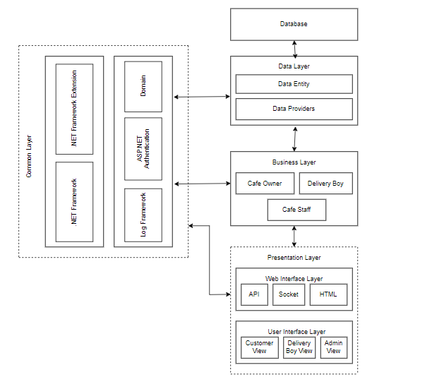

Figure 4.1[Component Diagram]

The RESTFUL architecture style provides core functionalities of the system as web services for different devices and platforms as mentioned in requirements R1, R2 and R5. The MVVM pattern [7] allows developing the User Interface (UI) with clear separation of UI components and presentation logic. The core system has three main layers: Data Layer, Business Layer and Presentation Layer. The Presentation Layer is further divided into two layers, namely Web Interface and UI Layers. These two layers are loosely coupled and connected with web services. All these layers are cross-connected with the Common Layer, as shown in Figure 4.1.

* 1. **DFD ON CAFTERIA MANAGEMENT SYSTEM:**
* Level Zero Diagram:

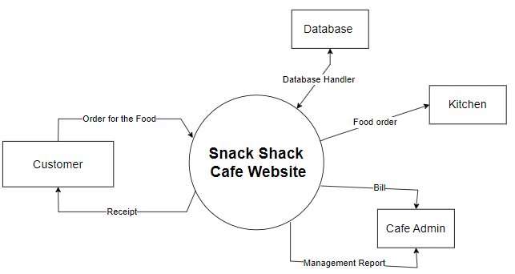

Figure 4.1.1[Level Zero DFD]

* Level One Diagram:

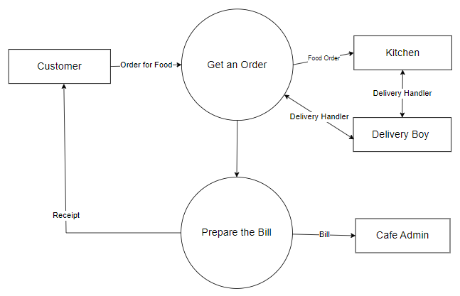

Figure 4.1.2[Level 1 DFD]

* Level Two Diagram:

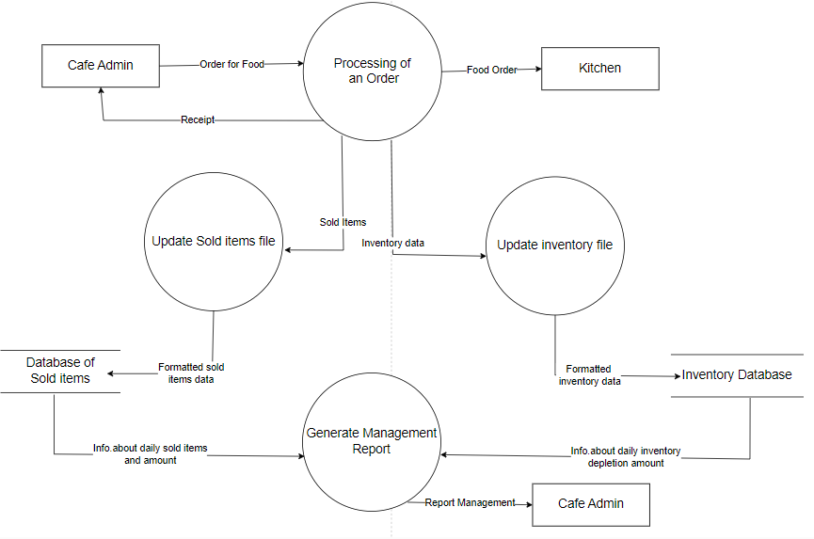

Figure 4.1.3[Level 2 DFD]

* 1. **Use Case Diagram:**

Use-case diagrams describe the high-level functions and scope of a system. These diagrams also identify the interactions between the system and its actors. The use cases and actors in use-case diagrams describe what the system does and how the actors use it, but not how the system operates internally.

Here users and admin are the actors and the working of the system is use cases.

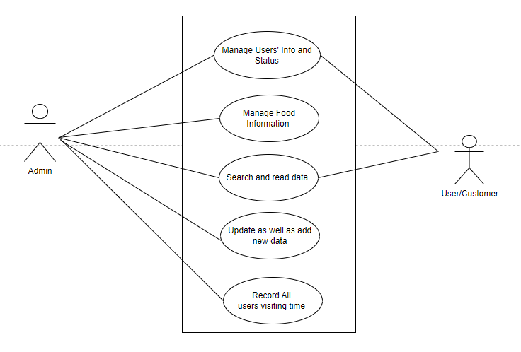

Fig 4.2.1[use case diagram]

* 1. **Sequence Diagram:**

A sequence diagram is a type of interaction diagram because it describes how—and in what order—a group of objects works together. These diagrams are used by software developers and business professionals to understand requirements for a new system or to document an existing process. Here this sequence diagram shows how the system works in step by step.

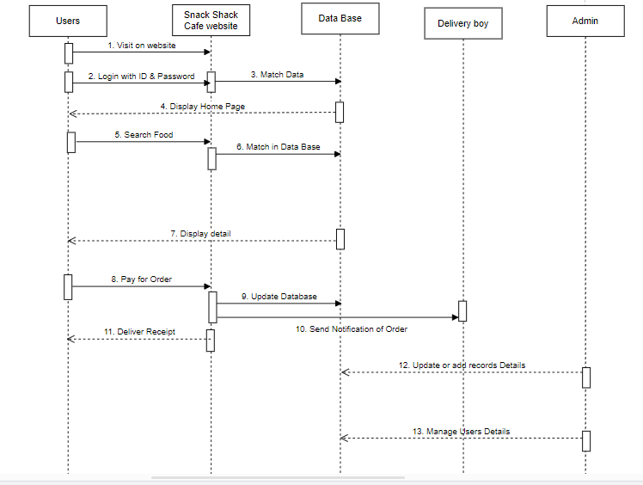

Fig 4.3.1 [Sequence Diagram]

Edition”, Canada, 1997.